**Risk Assessment**

Purbeck Valley Farm

Updated - 10.06.2019

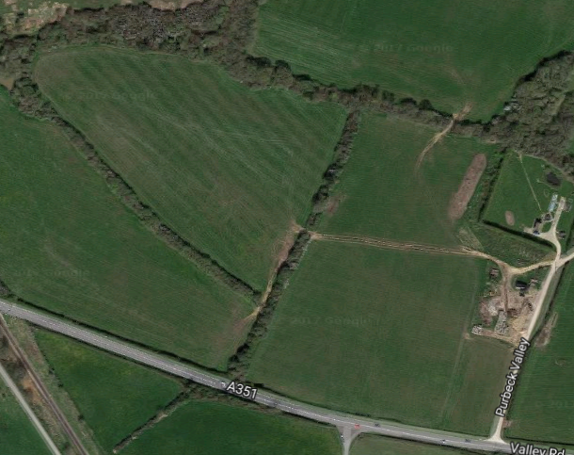

The site consists of:

Main camping field

Access to the camping field.

This is a private site and as such access for the public is not permissible.

|  |  |  |
| --- | --- | --- |
| **Hazard** | **Example Causes** | **Control Measures** |
| **Fire** | Naked flame use in tents.  Poorly maintained electrical equipment. | Briefing on arrival  Fire extinguishers and suitable equipment will be provided at each camp and in around catering tent and facilities. Serviced annually by a reputable provider.  Appropriate signage. |
| **Personal Injury & Illness** | Use of outdoor elements  Trip hazards  Ticks | Signage and protocol to prevent the use of outdoor equipment without qualified instructor.  On-going management by camp leader to ensure hazards are removed or minimised.  Fencing around key hazards - LPG tank, CessPit plus clear signage outlining the dangers.  Boiler serviced annually at the start of each season (April) by a registered gas engineer. (Gas Safe Register - <https://www.gassaferegister.co.uk/>)  Electrical circuits tested annually at the start of each season (April) by a qualified electrician - <http://www.niceic.com/>  Vehicle access to main campsite to be limited. Speed of vehicles limited on site to 10mph. |
| **Hygiene** | Poor level of guest hygiene  Dirty facilities  Contaminated water  Catering | Briefing on arrival.  Regular inspection and cleaning of facilities.  Hand washing facilities available with soap.  Water sampling - with specific reference to legionella to be carried out annually at the start of each season.  Catering is outsourced, check in with their processes to ensure good practice. |
| **Security** | General public entering site  Students walking off-site | The campsite is private (the general public  are not permitted)  Staff to question people who are not recognised.  The area is fenced and gated.  Land & Wave staff will be present overnight.  Appropriate signage and briefing.  Groups allocated specific area. |